|  |
| --- |
| Zapna |
| User Guide Book |
| Understanding the Portals and key functionalities |
|  |
| **Updated** |
| **6/26/2012** |

|  |
| --- |
| This document provides an understanding of Zap |

Contents

[Login: 5](#_Toc328492315)

[B2B: 6](#_Toc328492316)

[Companies List: 6](#_Toc328492317)

[Employees List: 11](#_Toc328492318)

[Payment History: 14](#_Toc328492319)

[Refill: 14](#_Toc328492320)

[B2C: 15](#_Toc328492321)

[All Registered Customer: 15](#_Toc328492322)

[Charge Customer: 18](#_Toc328492323)

[Refill Customer: 19](#_Toc328492324)

[Payment History: 20](#_Toc328492325)

[Agents: 21](#_Toc328492326)

[Company List: 21](#_Toc328492327)

[User List: 26](#_Toc328492328)

[Agent per Product: 28](#_Toc328492329)

[Agent Commission Package: 29](#_Toc328492330)

[Refill Agent Company: 30](#_Toc328492331)

[Charge Agent Company: 30](#_Toc328492332)

[Payment History: 31](#_Toc328492333)

[Updates: 32](#_Toc328492334)

[List All Updates: 32](#_Toc328492335)

[FAQ: 34](#_Toc328492336)

[User guide: 35](#_Toc328492337)

[Reports: 38](#_Toc328492338)

[Low Credit Alert Report: 38](#_Toc328492339)

[Admin Users: 39](#_Toc328492340)

[User: 39](#_Toc328492341)

[Download: 40](#_Toc328492342)

[Download User Guide: 40](#_Toc328492343)

[Settings: 42](#_Toc328492344)

[Postal Charge: 42](#_Toc328492345)

[Products: 44](#_Toc328492346)

[Country List: 47](#_Toc328492347)

[City: 49](#_Toc328492348)

[SMS Text: 51](#_Toc328492349)

[Low Credit Alert: 53](#_Toc328492350)

[Low Credit Alert Sender: 56](#_Toc328492351)

[Telecom Operator: 58](#_Toc328492352)

[Deactivate Customer: 60](#_Toc328492353)

[Transaction Description: 61](#_Toc328492354)

[Edit B2B Credit Limit: 63](#_Toc328492355)

[Logout: 64](#_Toc328492356)

**Preface**

This document provides an understanding of popular features of Zapna No portals that revolves around a unique product called smarter sim. This product facilitates the consumer to make cheap international calls.

Smarter Sim is a thin chip, when attached to a mobile phone SIM card, allows making international calls via the VoIP provider's routes. It fits most types of mobile GSM phones. Smarter Sim does not require Wi-Fi, 3G, or GPRS Internet connection, eliminating the need for a Smart phone to use VoIP services on the go. Smarter Sim is an excellent solution for VoIP providers to expand their services to mobile phone clients. The main advantage of the Smarter Sim chip is that it eliminates the need to dial an access number, and to listen and interact with the IVR, making calls to international numbers much easier compared to calling cards and PINLESS services. Smarter Sim users can dial international numbers directly from their phone book. When a user dials an international phone number, the chip automatically reroutes the call to the VoIP provider’s access number and the call connects via the VoIP routes.

**Admin Portal:**

Using Admin Portal, it is possible to register B2B companies and their employees. In this portal, agent companies and their users are also registered. Facilities are provided like, managing agent commissions, product packages, cities, countries, telecom operator and many more.

**Admin Portal**

Key features of Admin Portal are following:

* Register B2B Company and its employee.
* Agent Company can be created. Admin can create agent company users and define the commission packages of Agent Company.
* Customer details can be viewed of all registered B2C customers.
* Admin can handle the News Updates, FAQ and User guide and all these information’s are displayed on agent portal.
* Admin can also create users to access Admin Portal.
* Other settings
  + Defining the Product packages
  + Country and Cities.
  + SMS Text module for creating and updating the SMS text which is sent to customers.

## Login:

Enter Email and password and then click on ***login*** button to access Admin Portal.

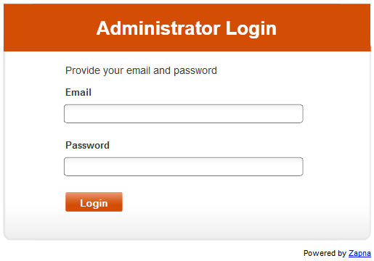



# B2B:

In B2B Company, multiple companies and their employees can be registered on Zapna No and can be used the services of Zapna No.

## Companies List:

Click on ***Companies List*** from B2B dropdown menu to see list of companies which are registered on Zapna No.



**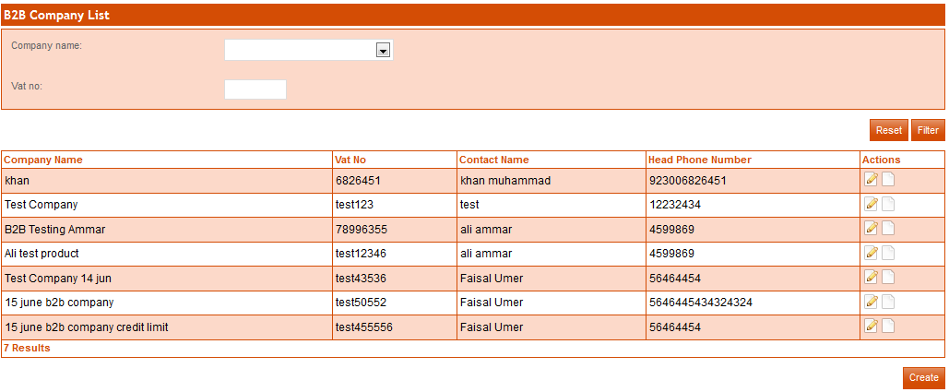**

**Filter Company:**

**By Company Name:**

To search/filter the company by name select company name and then click on ***filter*** button. Result will be shown for selected company.

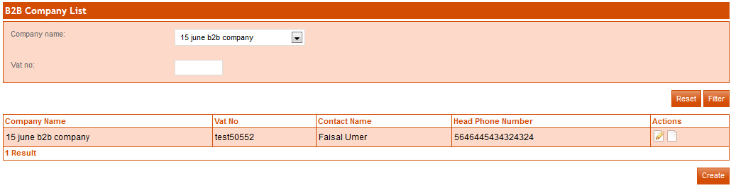

**By Vat No:**

To search/filter the company by Vat No, enter company’s Vat No and then click on **filter** button. Result will be shown for entered vat no.

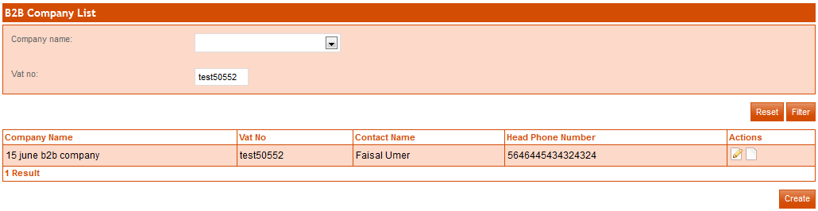

**Reset Company:**

After filter if you want to see all companies than click on **Reset** button, all registered companies will be shown. 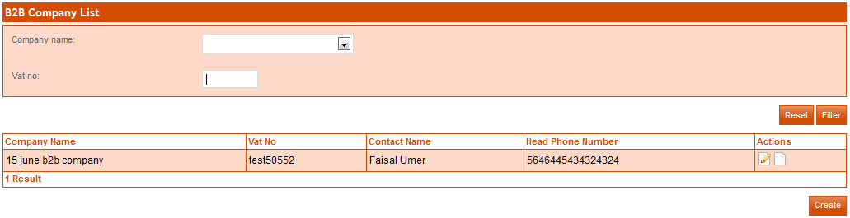

**Create Company:**

To create new company, Click on **Create** button. On next page a form will be shown. Enter mandatory fields in form and click on **save** button. If you want to add more companies then after enter records click on **Save and Add** button. (**Mandatory fields are in bold**).



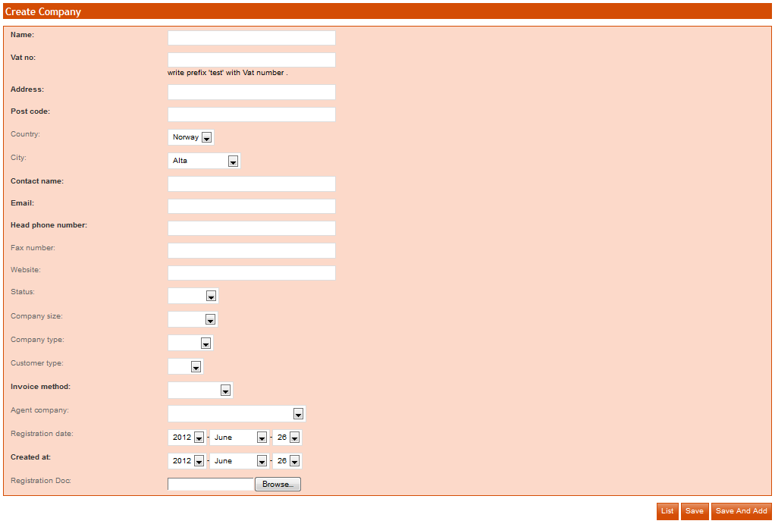

Name: Enter company name in this field

Vat No: Enter Vat no in this field, vat must be in digits.

Address: Enter address of the company in this field.

Post Code: Enter post code in this field.

Contact Name: Enter the name of Contact Person in this field.

Email: Enter the valid email address in this field.

Head Phone No: Enter the head phone no in this field.

Created At: Select date from drop down menu.

**Edit Company:**

To edit company info click on  button. Modify your required fields in form and click on ***save*** button. If you want to add more companies then after modification click on ***Save and Add*** button.

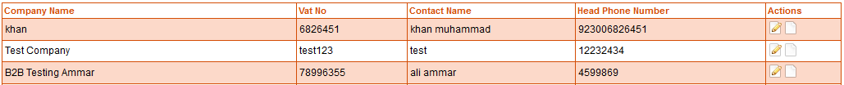

**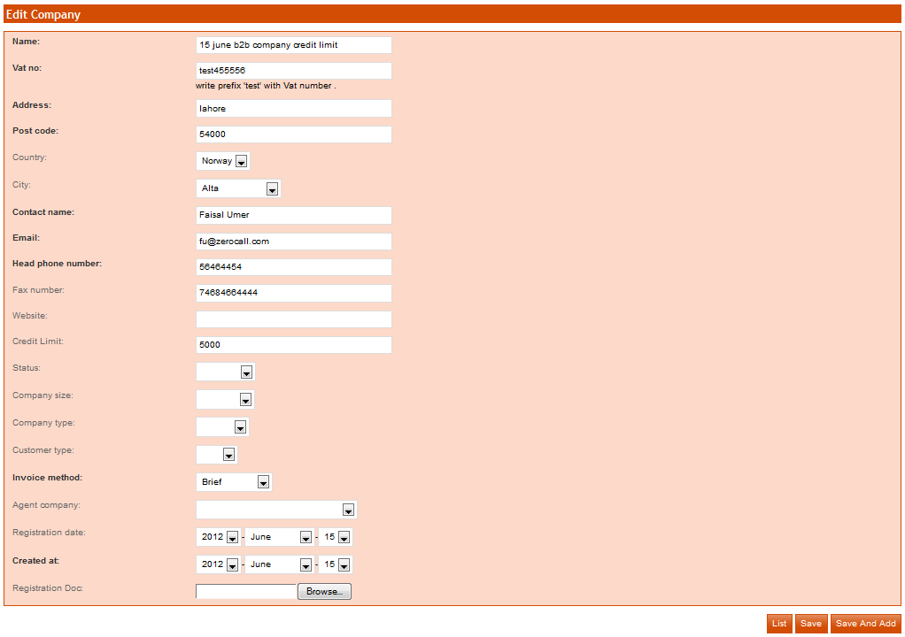**

**View Company Detail:**

To view company detail, click on D:\wamp\www\Norway\web\sf\sf_admin\images\edit_icon.png icon.



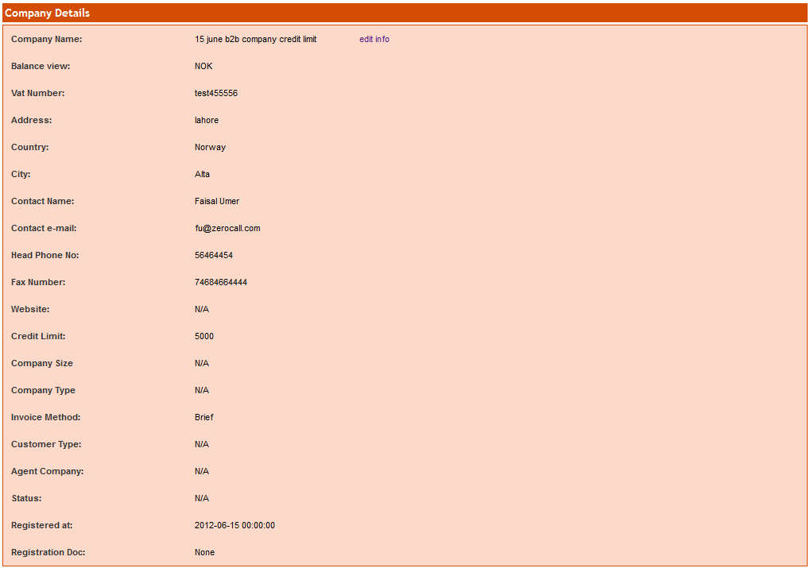

**View Company Employee:**

To view employee list of specific company, click on **Employees** button.



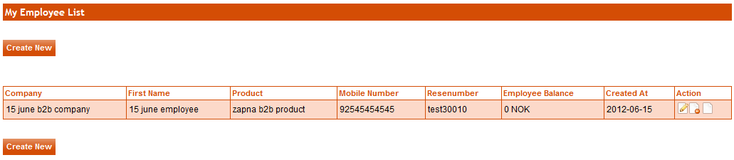

**View Company Call History:**

To view company Call History, click on **Usage** button.



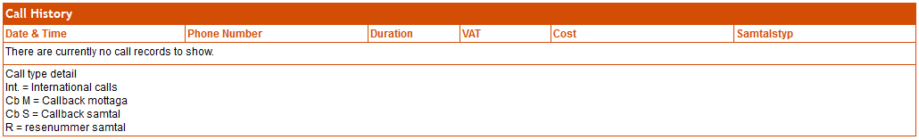

**View Company Payment History:**

To view payment history, click on **Payment History** button.



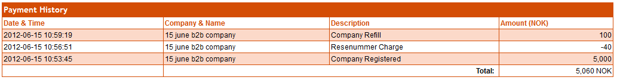

## Employees List:

Click on **Employee Lists** from B2B dropdown menu to see list of employees of different companies.



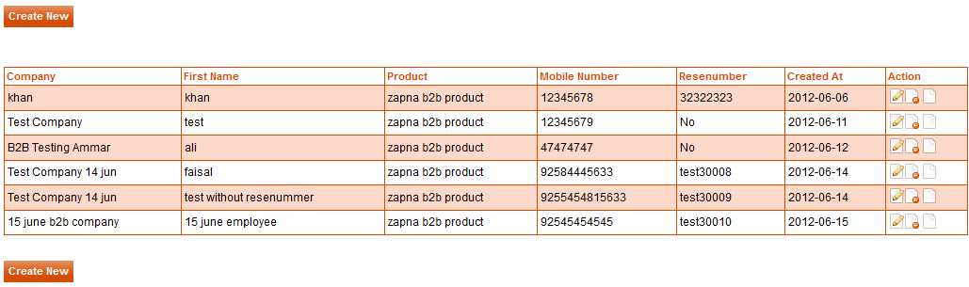

**Create Employee:**

Click on **Create New** button to create new employee. Enter mandatory fields (First Name, Last Name, Mobile Number and Email)

****

**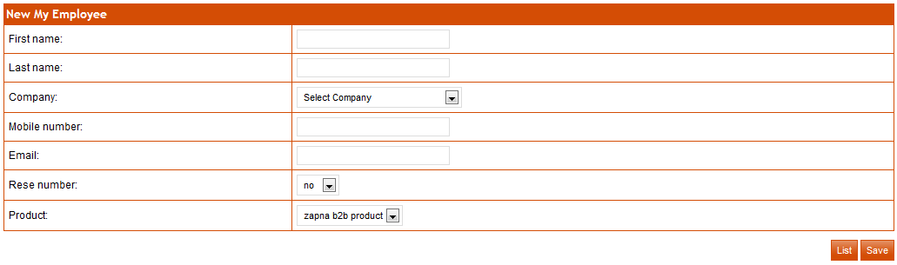**

**Edit Employee:**

To update employee’s information, click on Edit D:\wamp\www\Norway\web\sf\sf_admin\images\edit_icon.png button from end of respective employee record. A form will be shown with employee’s existing info. Change required information and click on **Update** button.

**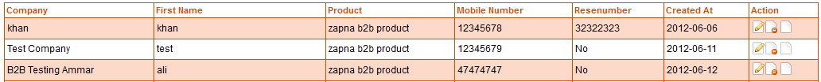**

**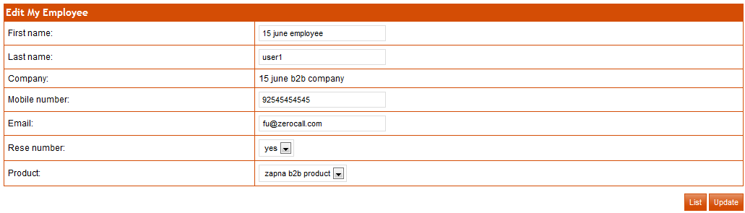**

**Delete Employee:**

Admin can also delete the employee. To delete employee, click on **DeleteD:\wamp\www\Norway\web\sf\sf_admin\images\delete_icon.png** button.



**View Employee Detail:**

To view employee detail, click on Detail D:\wamp\www\Norway\web\sf\sf_admin\images\default_icon.pngbutton. All info of employee will be displayed.



**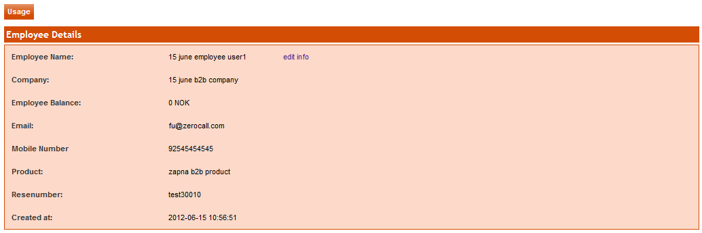**

**Call History:**

To view the history of employee, click on button. Call History of 15 days will be displayed of specific employee.

**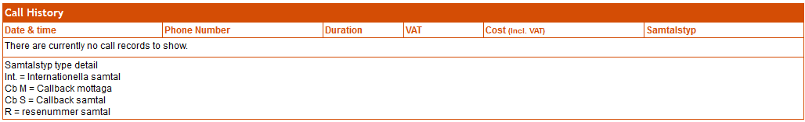**

## Payment History:

To view payment history of all registered companies click on **Payment History**.

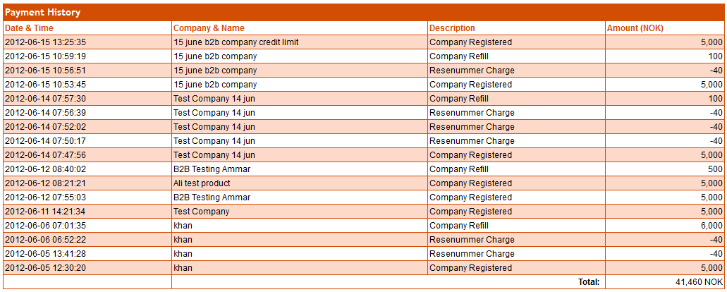

## Refill:

Admin can also refill any company. To refill the company click on **Refill** under B2B tab*.* Select company and enter amount in refill field then click on **save** button

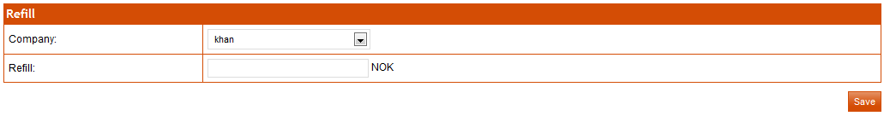

# B2C:

## All Registered Customer:

To view registered customer list, click on **All Registered Customer** under Zapna No. List of all registered customer will be displayed.

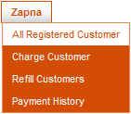

**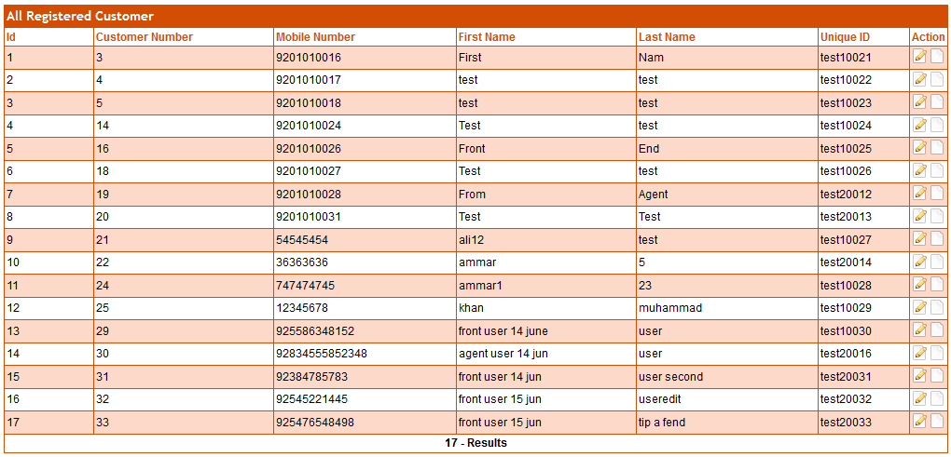**

**Edit Customer:**

To edit customer info click on D:\wamp\www\Norway\web\sf\sf_admin\images\edit_icon.png button. Modify your required fields in form and click on ***update*** button. 

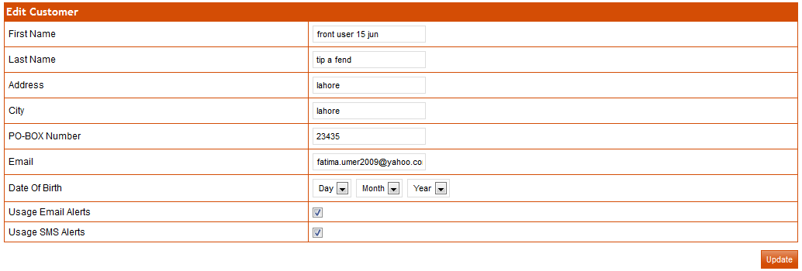

First Name: Change the first name of customer, if u required.

Last Name: Change the last name of customer, if u required.

Address: Change the address of customer, if u required.

City: Change the city of customer, if u required.

PO-BOX Number: Change the po-box no of customer, if u required.

Email: Change the email address of customer, if u required.

Date of Birth: Change the date of birth of customer, if u required.

Usage Email Alerts: If you want to send the email of low balance to customer, checked on usage email alerts.

Usage SMS Alerts: If you want to send the SMS of low balance to customer, checked on usage SMS alerts.

**Customer Detail:**

To view customer detail, click on **View** button. Detail customer info will be displayed.

**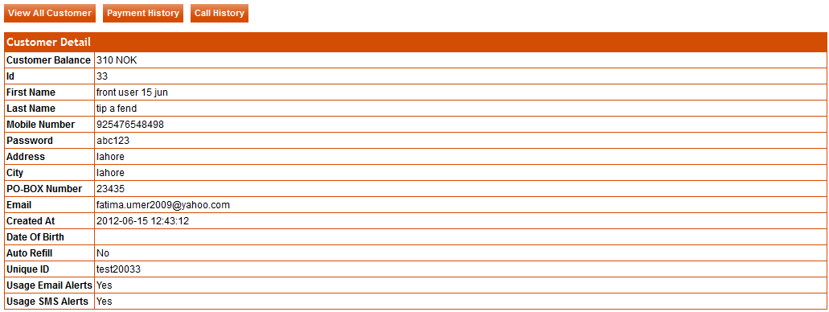**

**Payment History:**

To view payment history, click on **Payment History** button. All payment history of specific customer will be displayed

****

**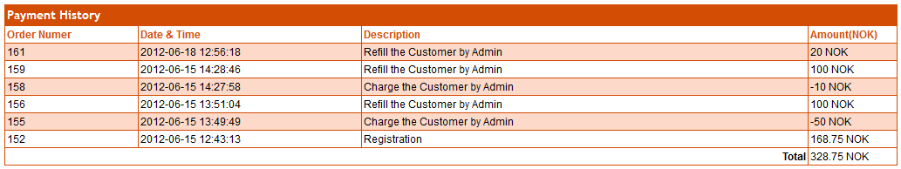**

**Call History:**

To view call history, click on **Call History** button. Call history can be filtered against selected dates of a specific customer.

****

**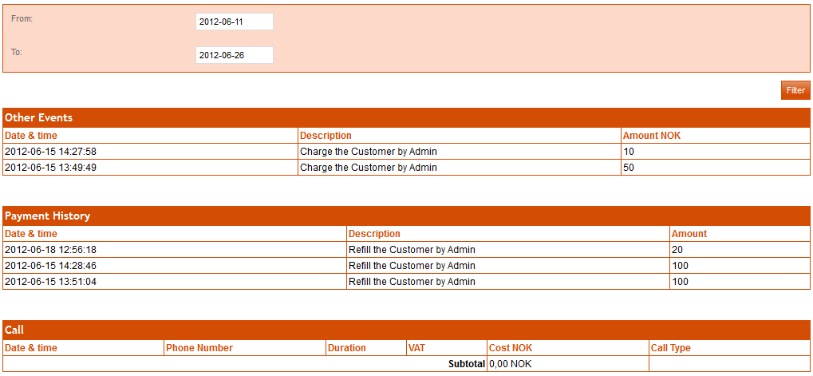**

## Charge Customer:

To charge the customer, enter Customer Number, select Transaction Description, enter the Charge amount in the field and click on **Charge Customer** button.

****

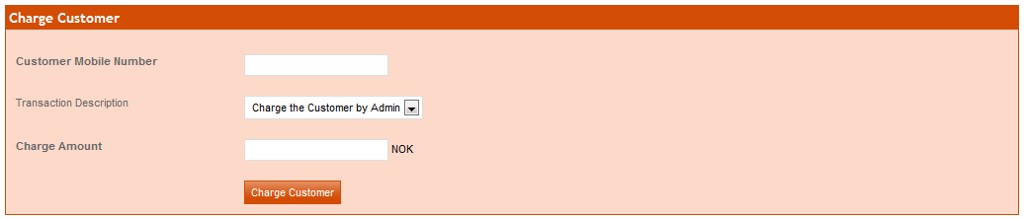

## Refill Customer:

To refill the customer, enter Customer Number, select Transaction Description, enter the refill amount in the field and click on **Refill Customer** button.



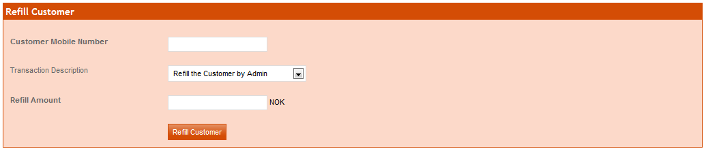

## Payment History:

To view payment history, click on **Payment History** button. Payment history can be filtered against selected dates of a specific customer or type of transaction Description.



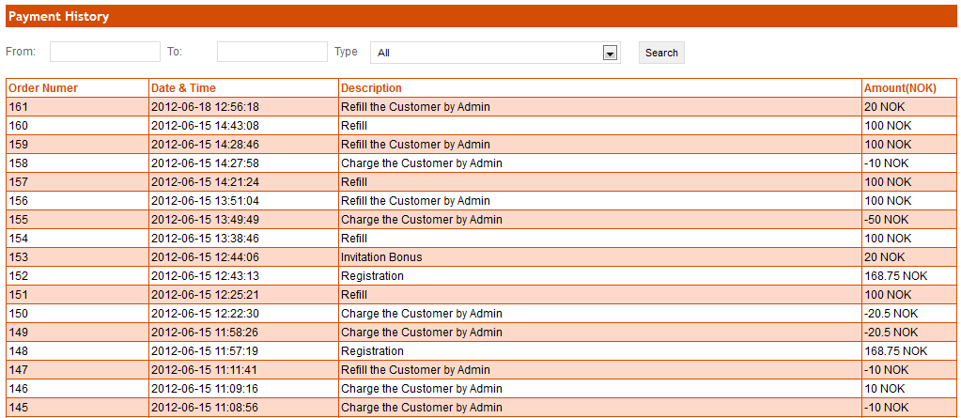

# Agents:

## Company List:

To view Agent Company info click on Company List. All Agent Company info will be display.

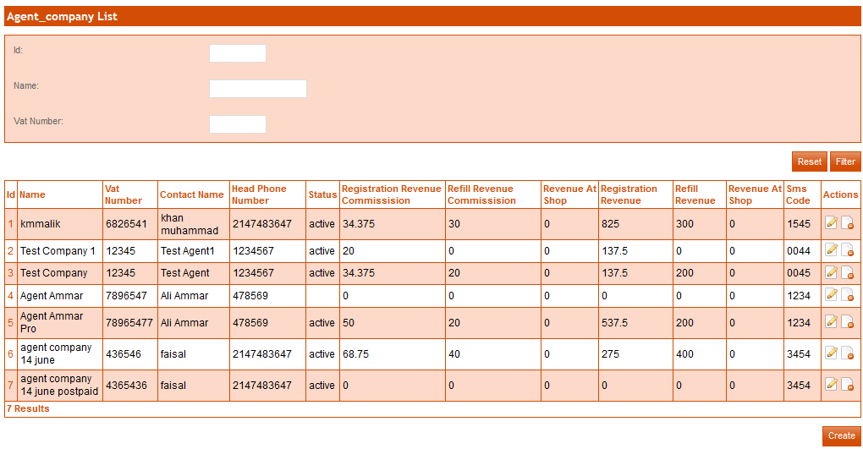

**Filter Agent Company:**

**By Id:**

To search/filter the agent company by id, enter id and then click on **filter** button. Result will be show of specific agent company.

**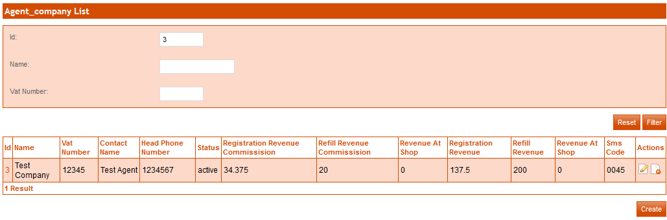**

**By Name:**

To search/filter the agent company by name; enter name and then click on **filter** button. Result will be shown of specific agent company.

**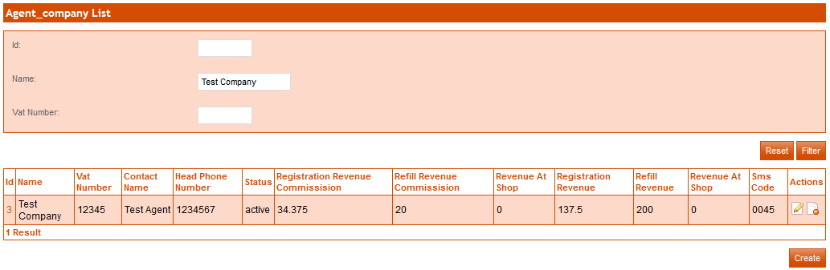**

**By Vat Number:**

To search/filter the agent company by vat no; enter vat no and then click on **filter** button. Result will be shown of specific agent company.

**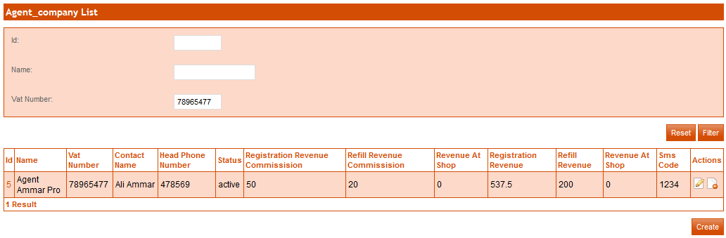**

**Create Agent Company:**

To create an agent company, click on **create** button. A form will be display, enter mandatory fields in the form. Then click on **save** button. If you want to enter more agent company then click on **save and add** button. (Mandatory fields are in bold)

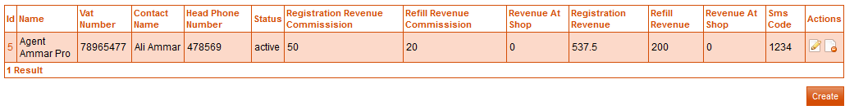

**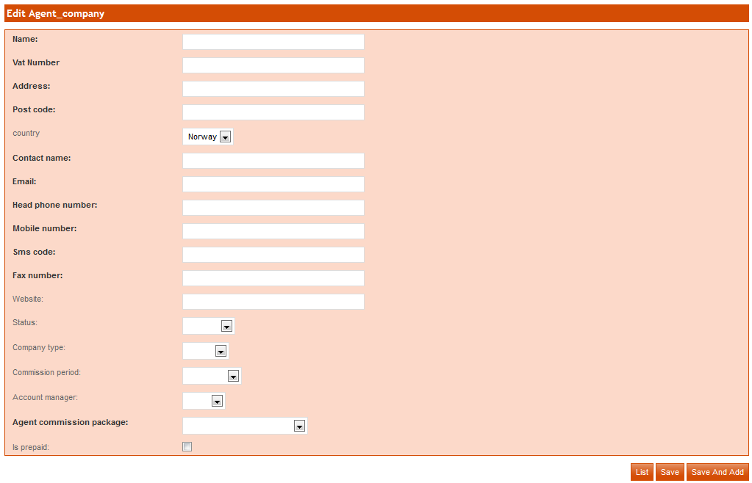**

Name: Enter agent company name in this field.

Vat No: Enter vat no in this field.

Address: Enter address in this field.

Post Code: Enter post code in this field.

Contact Name: Enter contact name in this field.

Email: Enter email address in this field

Head phone number: Enter head phone number in this field.

SMS code: Enter SMS code in this field.

Fax number: Enter fax number in this field.

Agent Commission Package: Select agent commission package, which is used to mention the commission amount of Agent Company.

Is prepaid: If Agent Company already pays to Zapna No support, click on is prepaid checkbox,

Balance: Enter the Agent Company balance in this field.

**Edit Agent Company:**

To edit an agent company, click on **editD:\wamp\www\Norway\web\sf\sf_admin\images\edit_icon.png**button. A form will be display, update required fields in the form. Then click on **save** button. If you want to enter more agent company then click on **save and add** button.

**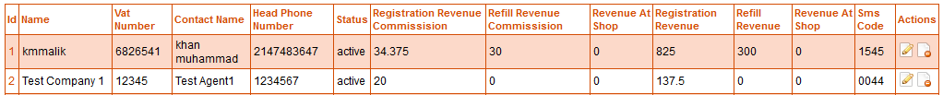**

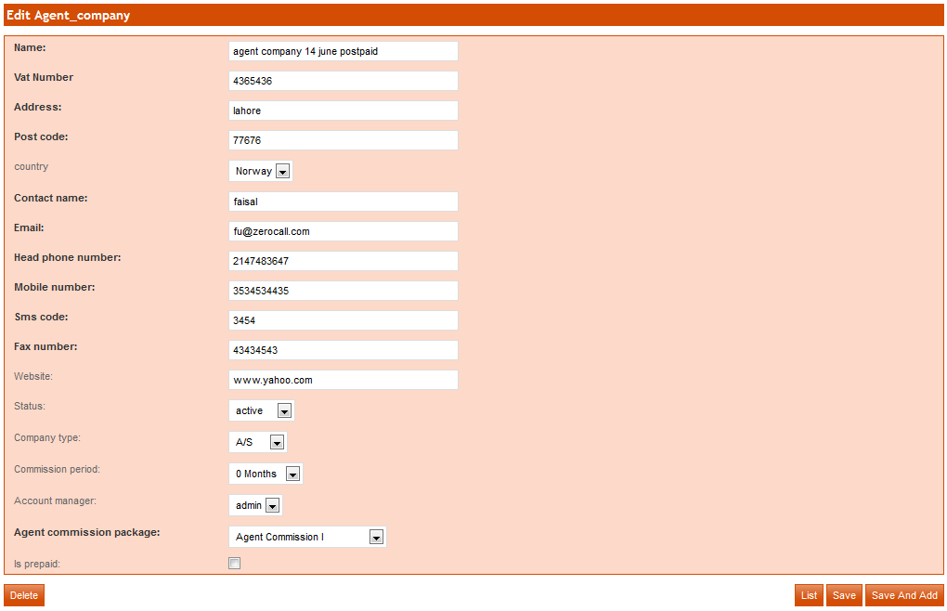

## User List:

To view user list of Agent Company, click on user list. All lists of users will be display.

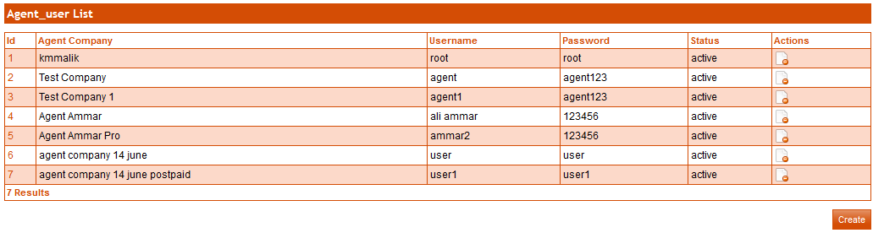

**Create User:**

To create user of agent company click on **Create** button, a form will be show enter mandatory field and then click on **Save** button. If you want to add more users than click on **save and add button***.* (Mandatory fields are in bold)

****

**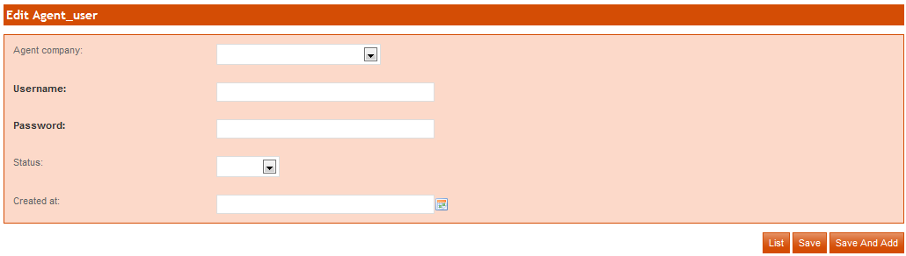**

Agent Company: Select Agent Company.

Username: Enter username, which is used to login the agent portal.

Password: Enter password, which is used to login the agent portal.

Status: Enter the status of user.

Created At: Select date from calendar to enter in this field.

**Edit User:**

To edit user of agent company click on **Id** of specific user which you want to update, a form will be shown update required fields and then click on **save** button. If you want to add more users than click on **Save and Add** *button.*

**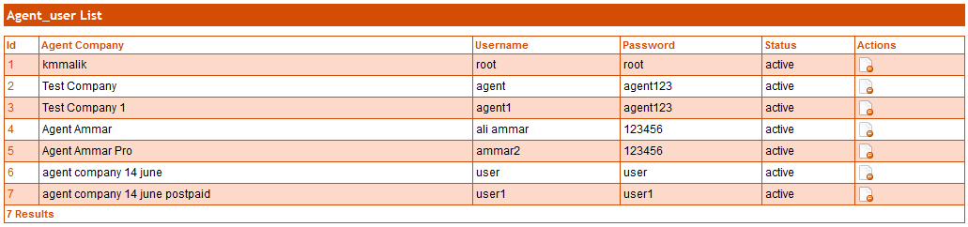**

**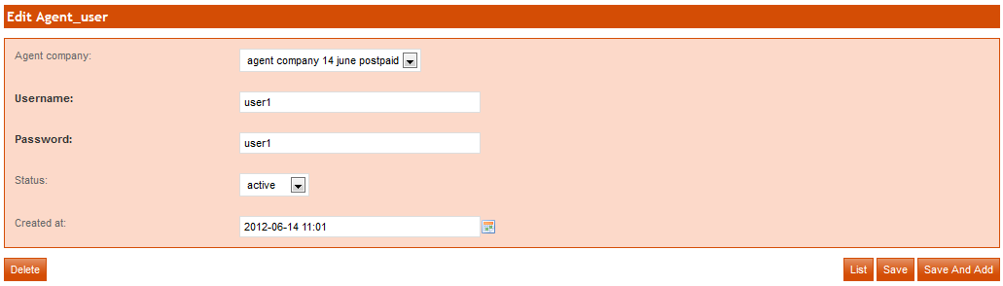**

**Delete User:**

If you want to delete user then click on **DeleteD:\wamp\www\Norway\web\sf\sf_admin\images\delete_icon.png**button.



## Agent per Product:

This module provides the facility to give commission to Agent Company on the basis of product they sell or refill. We can customize the value of commission to be given to a particular agent company, of any particular product, that company registers or refills. If you want to assign the package on the basis of per product, click on agent per product. Select Agent Company Id and click on assign product button. A new page will be open.

1. Click on checkbox on which product you want to assign to commission.
2. Enter **Reg share value**.
3. If you want to assign **Reg Share Value** in % than click on checkbox.
4. Then click on **Reg share enable** checkbox.
5. Enter ***Extra payments share value***.
6. If you want to assign **Extra payments share value** in% than click on checkbox.
7. Then click on **Extra payments share enable** checkbox.
8. And click on **Update** button.





**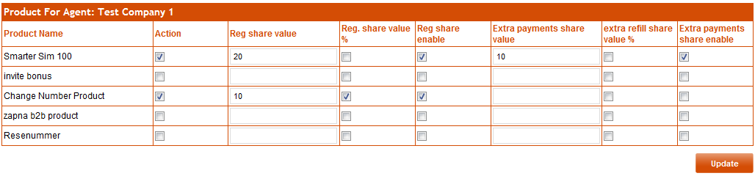**

## Agent Commission Package:

We can generalize the commission awarded to agent companies by defining the packages. To view all commission packages of Agent, click on Agent Commission Package.

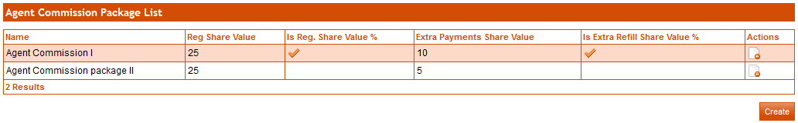

**Create Agent Commission Package:**

To create commission package of agent company click on **Create** button, a form will be show.

1. Enter package name.
2. Enter reg share value.
3. If you want to assign **Reg share value** in % than click on checkbox.
4. Enter **Extra payments share value***.*
5. If you want to assign **Extra refill share value** in % than click on checkbox.
6. Click on **save** button.
7. If you want to add more agent commission packages, click on **Save and add** button*.*

****

**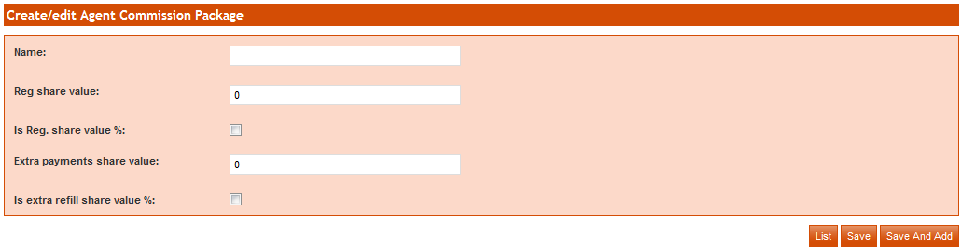**

## Refill Agent Company:

To refill the agent company, select Agent Company, select Transaction Description, and enter the refill amount in the field and click on **Refill Agent Company** button.



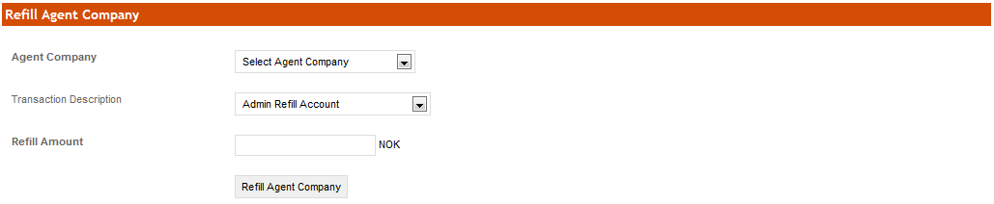

## Charge Agent Company:

To charge the agent company, select Agent Company, select Transaction Description, and enter the Charge amount in the field and click on **Charge Agent Company** button.



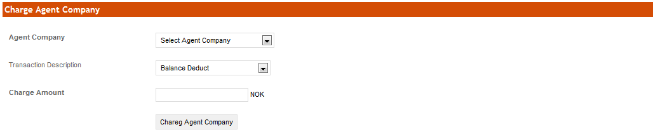

## Payment History:

To view payment history, click on **Payment History** button. Payment history can be filtered against selected dates of a specific agent company or type of transaction Description.





# Updates:

## List All Updates:

To view news updates info click on **List All Updates**. All News updates info will be display. These news updates will be shown in Agent Portal.



**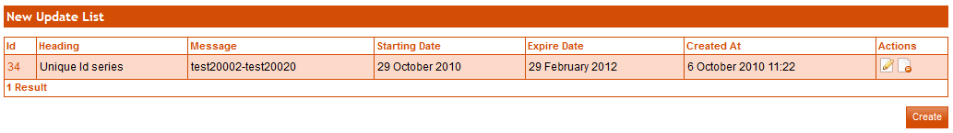**

**Create News Updates:**

To create news updates click on **New Update** button, a form will be show enter required info in fields and then click on **Create** button.



**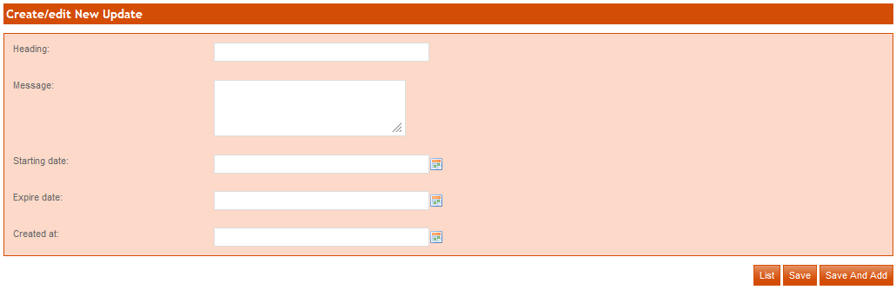**

**Edit News Updates:**

To edit news updates click on **Edit D:\wamp\www\Norway\web\sf\sf_admin\images\edit_icon.png** button, a form will be show update required info in fields and then click on **update** button.

****

**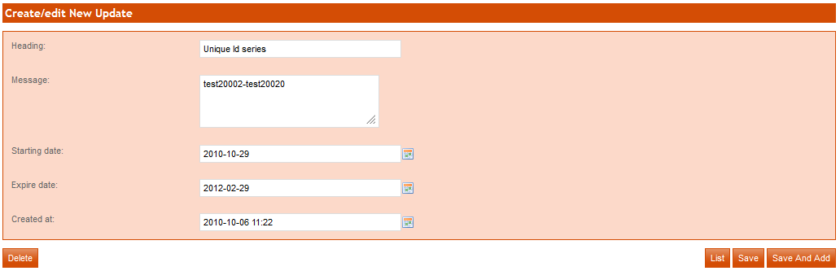**

**Delete News Updates:**

If you want to delete news updates then click on **Delete D:\wamp\www\Norway\web\sf\sf_admin\images\delete_icon.png** button.



## FAQ:

To view FAQ info click on **FAQ**. All FAQs will be display.



**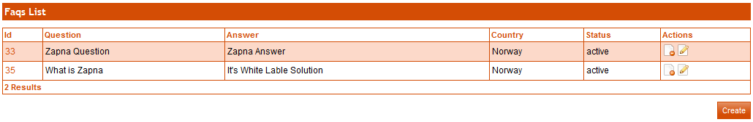**

**Create FAQ:**

To create FAQ click on **Create** button, a form will be show enter required info in fields and then click on **Save** button. If you want to add more FAQ than click on **Save and add** button*.* (Mandatory fields are in bold text)



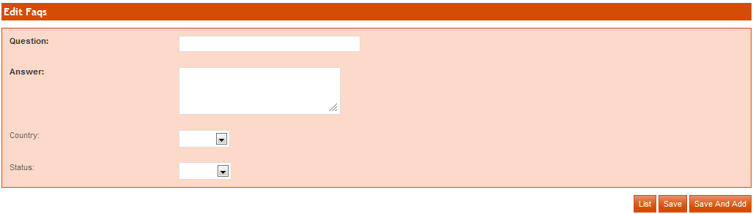

**Edit FAQ:**

To edit FAQ, click on **Edit** button.

**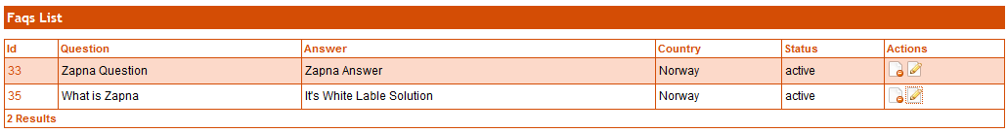**

**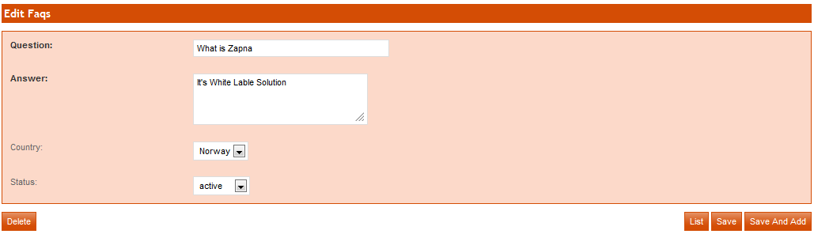**

**Delete FAQ:**

To delete FAQ, click on Delete D:\wamp\www\Norway\web\sf\sf_admin\images\delete_icon.png button.

****

## User guide:

User guide module provides the feature to add, update and delete User guide info.



**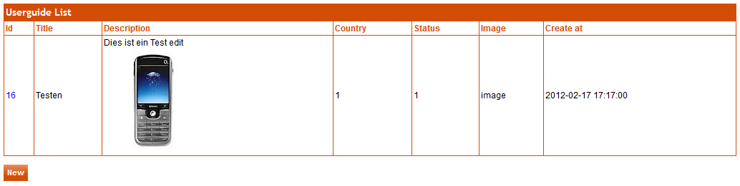**

**Create User guide:**

Enter mandatory fields and click on ***save*** button. (Title, Description and Image are mandatory fields)



**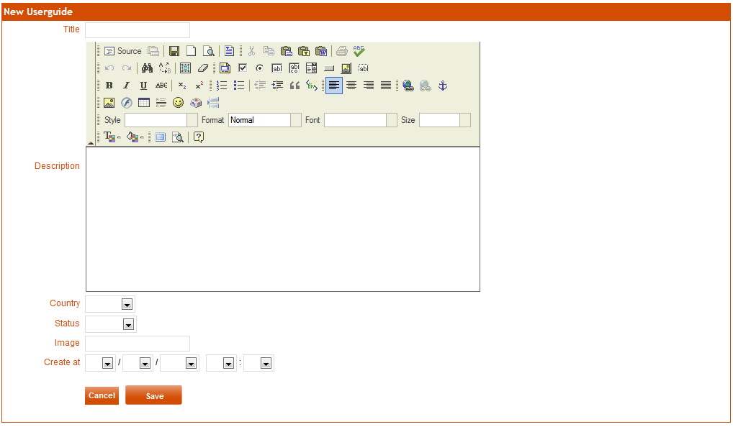**

**Edit User guide:**

To edit user guide, click on **Id.** Edit fields and click on **save** button. If you don’t want to save changes then click on **Cancel** button and if you want to delete user guide then click on **Delete** button.

**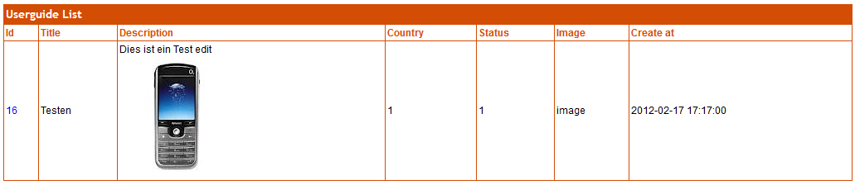**

**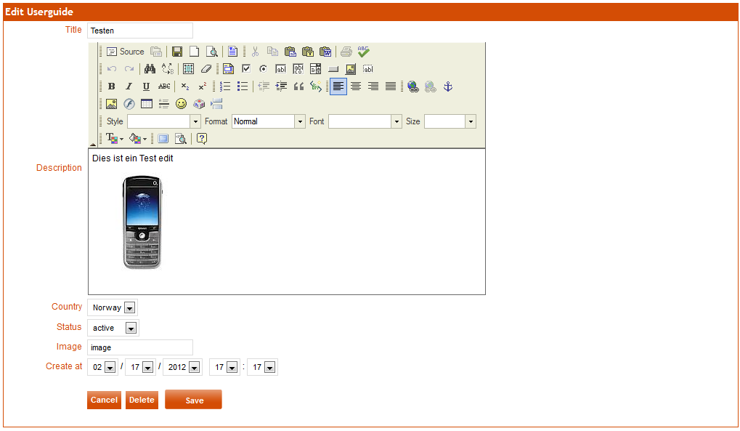**

# Reports:

## Low Credit Alert Report:

In low credit alert report, record exists of those customers who have low balance. To view usage report, click on *Low Credit Alert Report* Menu, select start and end date as you required and then click on *generate report*, all info will be displayed.

**Sent options for Email and SMS:**

Yes: when SMS and Email is checked by admin, than email and SMS will be sent to customer

No: if admin uncheck the Email or SMS, than Low balance Email and SMS balance will not sent to customer. Or if Email and SMS is checked by admin but customer does not receive SMS Email, than no option will be displayed.

**C:\Users\fatima\Desktop\Untitled-12 copy.png**

**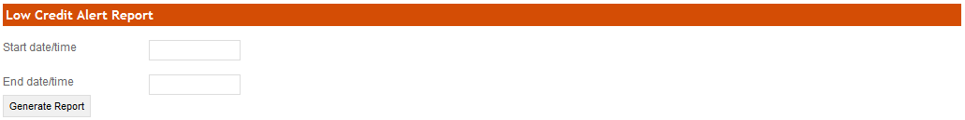**

**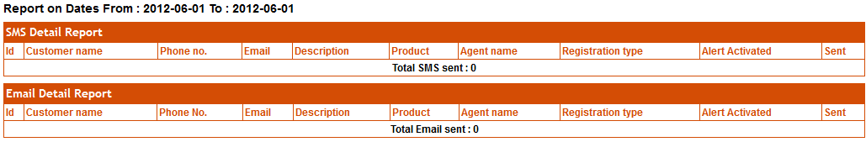**

# Admin Users:

## User:

This module provides the facility to add users which can access the Admin Portal. To view list of user click on *user* Module, all info will be shown.

C:\Users\fatima\Desktop\Untitled-3 copy.png

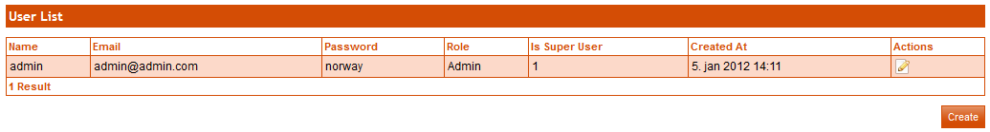

**Create User:**

To create new user, click on **Create** button. Enter mandatory fields and click on **Save** button. If you want to add more users then click on **Save and Add** button (mandatory fields have bold text)



**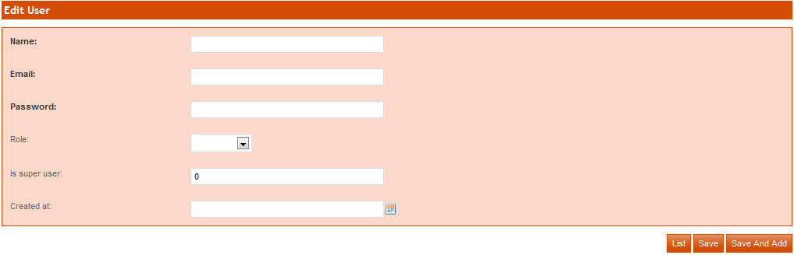**

**Edit User:**

To edit user, click on **EditD:\wamp\www\Norway\web\sf\sf_admin\images\edit_icon.png**button.

**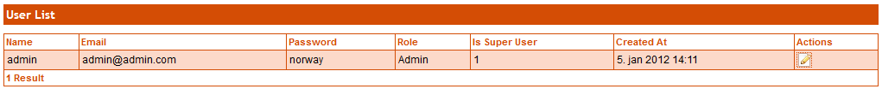**

**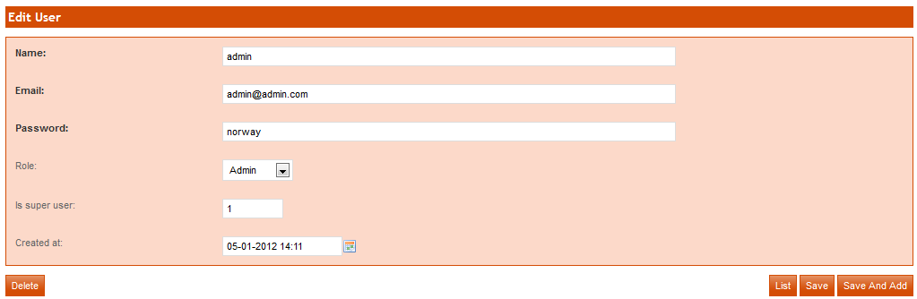**

# Download:

## Download User Guide:

To view the list of uploaded client documents, click on *Upload Client Document*. All lists will be displayed.

C:\Users\fatima\Desktop\Untitled-4 copy.png

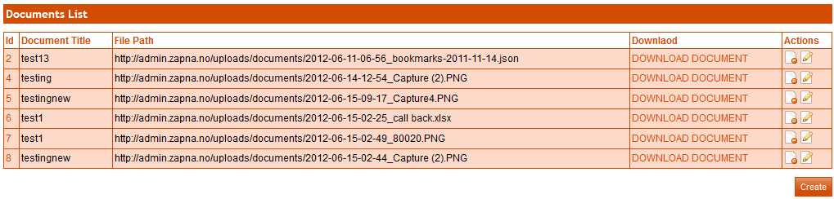

**Create User Guide:**

Click on ***Create*** button to add new document. A form will be display, enter document name, upload document and click on ***save*** button. 

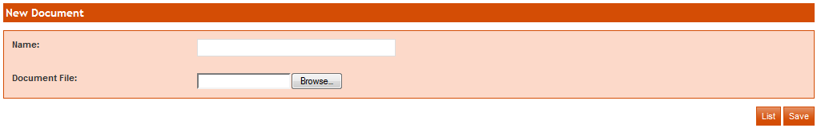

**Edit User Guide:**

To edit document, click on edit button. On next page change info then click on **save** button. 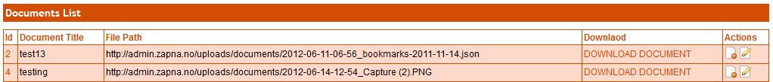

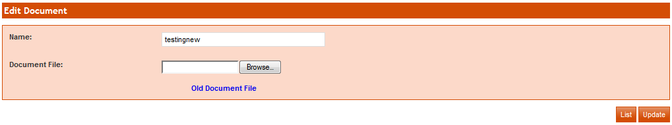

**Download User Guide:**

To download document, click on *Download Document*. 

**Delete User Guide:**

To delete document, click on *delete* button.



# Settings:

## Postal Charge:

To view the list of postal charges, click on *Postal Charges*. All lists will be displayed.

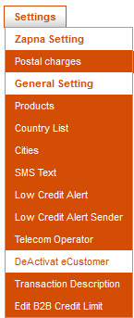

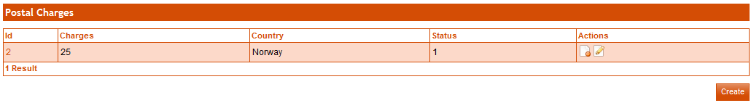

**Create Postal charges:**

To create postal charges, click on **Create** button. Enter mandatory fields and click on **Save** button. If you want to add more postal charges then click on **Save and Add** button



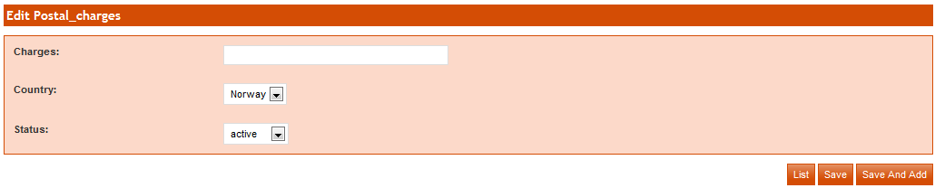

**Edit Postal Charges:**

To edit postal charges, click on edit button. On next page change info then click on **save** button.

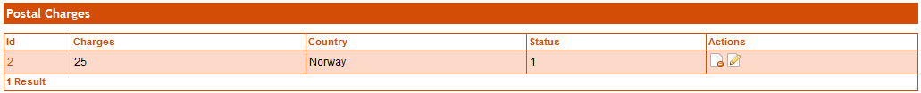

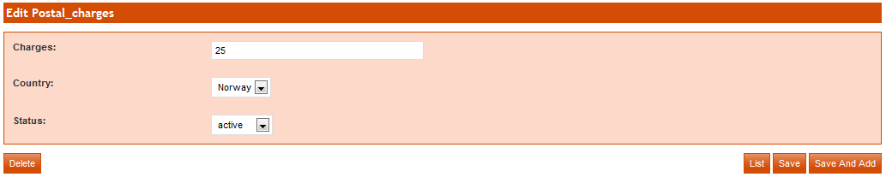

**Delete Postal Charges:**

To delete postal charges, click on *delete* button.



## Products:

This module provide the facility to add, update delete the products. To view all product lists, click on *Products* Module.



**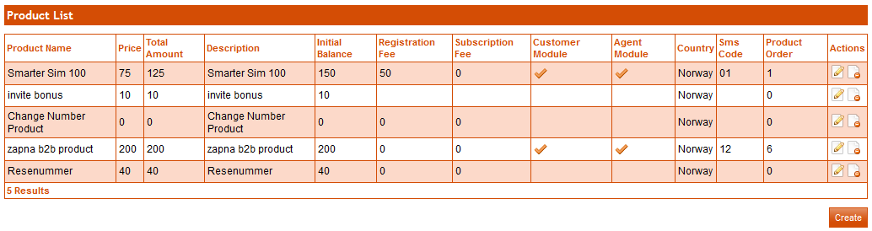**

**Create New Product:**

To create new product, click on Create button. Enter mandatory fields and click on **Save** button. If you want to add more product then click on **Save and Add** button.

****

**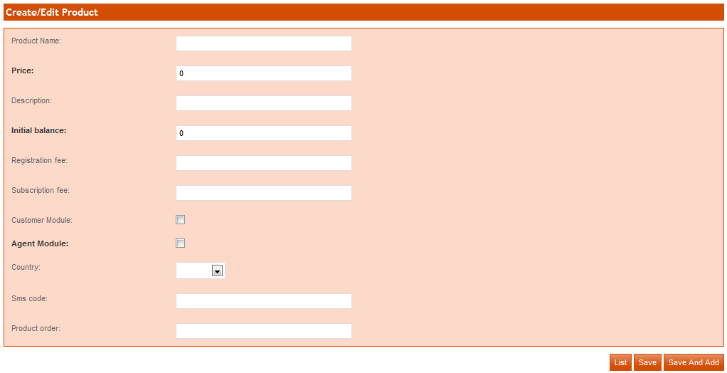**

Following are field description:

Registration fee: The amount that will be charged from customer against product.

Initial balance: The amount that will be given to customer after registration against product.

SMS code: This code is used to register customer via SMS.

Product order: This field is to set order of products to show on agent portal and/or customer portal.

Product Type Package: If set US package rather than bundle package than checked the checkbox.

Product Country Us: If users are us based than checked on this checkbox.

**Edit Product:**

To edit product, click on Edit D:\wamp\www\Norway\web\sf\sf_admin\images\edit_icon.png button. Make you changes and click on **save** button.

**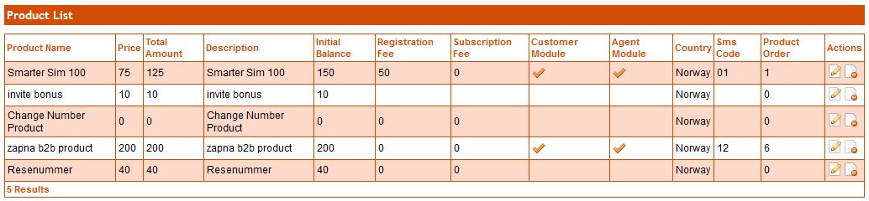**

**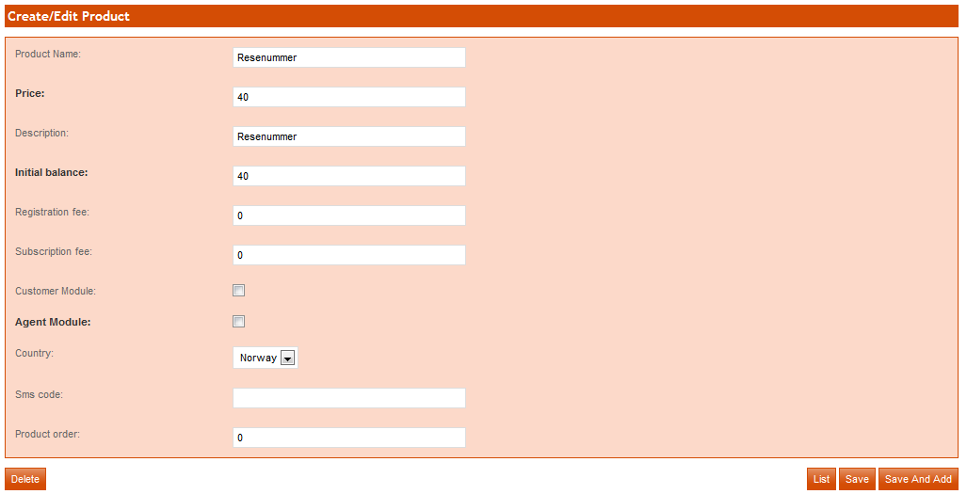**

**Delete Product:**

To delete product, click on Delete D:\wamp\www\Norway\web\sf\sf_admin\images\delete_icon.png button.



## Country List:

To access country List, click on *Country List* module. All details of country list will be shown. Country list consist of countries in which products will be sold.



**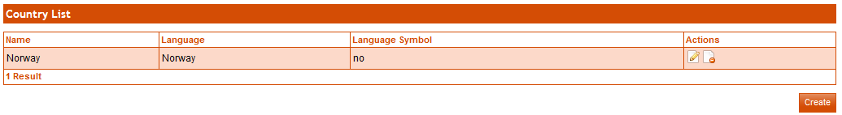**

**Create Country:**

Click on ***create*** button, to add new country**.** Enter mandatory fields and click on ***save*** button**.** If you want to add more country then click on ***Save and Add*** button.



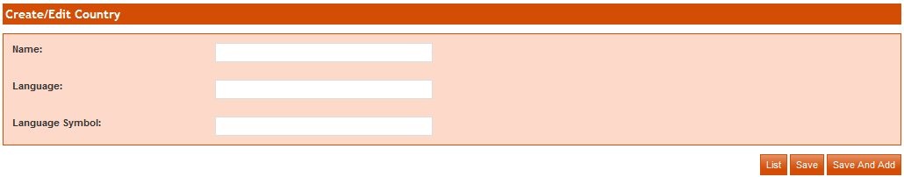

**Edit Country:**

Click on edit D:\wamp\www\Norway\web\sf\sf_admin\images\edit_icon.pngbutton and change information. After changing info, click on save button. If you want to add more country then click on ***Save and Add*** button.

**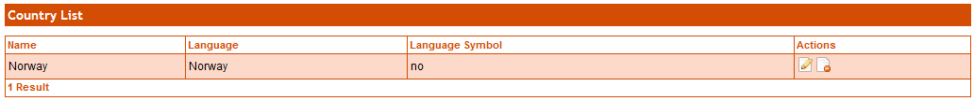**

**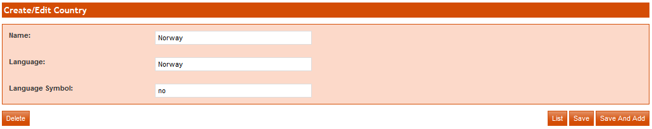**

**Delete Country:**

To delete country click on delete button that is end of country record on list page or on country edit page.





## City:

This module provides the facility to add, update and delete the city.

****

**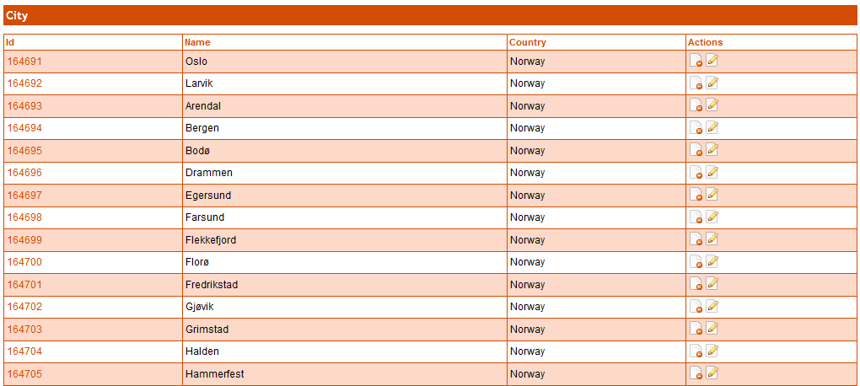**

**Create City:**

To create city click on **Create** button. Enter city name and select country name from given list then click on **Save** button. If you want to enter more cities then click on **Save and Add** button.

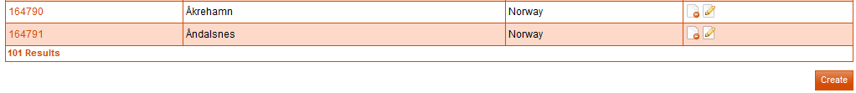

**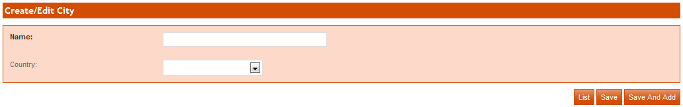**

**Edit City:**

To edit city, click on edit D:\wamp\www\Norway\web\sf\sf_admin\images\edit_icon.png button. Enter your changes and click on **save** button. If you want to enter new cities then click on **Save and Add** button.

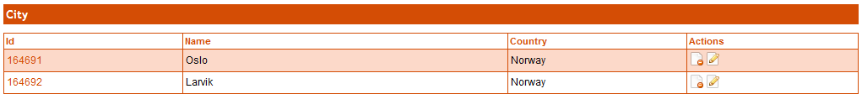

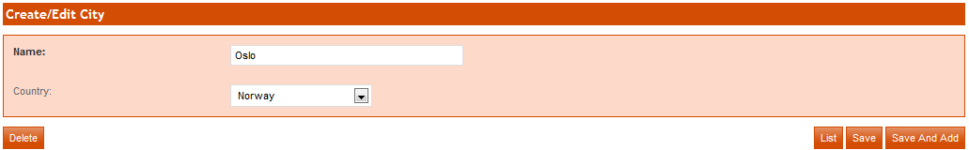

**Delete City:**

To delete city, click on delete button that is end of city record on list page or on city edit page.





## SMS Text:

This module provides the facility to add and update the SMS Text. These SMS texts will use to send SMS to customers and agents on various steps. To view all SMS, click on *SMS Text* Module

Change Number SMS: this SMS is triggered, when changed the customer number.



**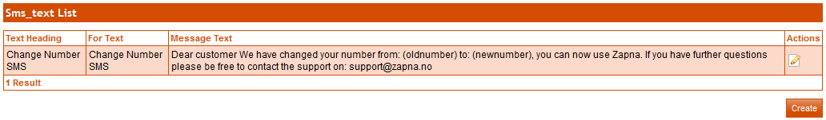**

**Create SMS Text:**

To create sms text, click on **Create** button. Enter mandatory fields and click on **Save** button. If you want to enter more sms texts then click on **Save and Add** button. (mandatory fields are in bold.)



**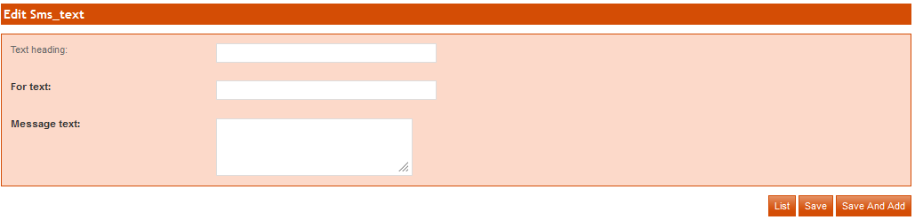**

**Edit SMS Text:**

To edit sms text click on Edit D:\wamp\www\Norway\web\sf\sf_admin\images\edit_icon.png button. On next page change your required info then click on **Save** button.If you want to enter more sms texts then click on **Save and Add** button.

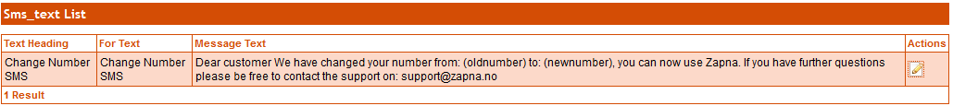

**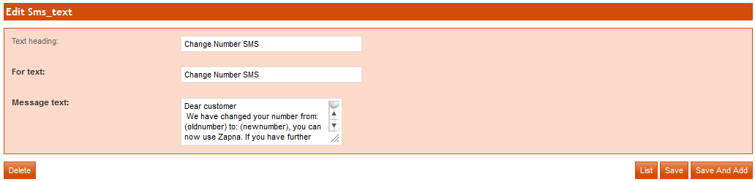**

## Low Credit Alert:

To view the list of low credit alert, click on *Low Credit Alert*.



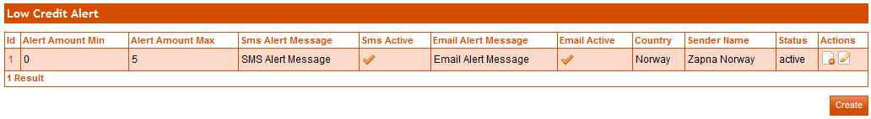

**Create Low Credit Alert:**

To create usage alert, click on **Create** button. Enter mandatory fields and click on **Save** button. If you want to enter more low credit alert, click on **Save and Add** button. (mandatory fields are in bold)



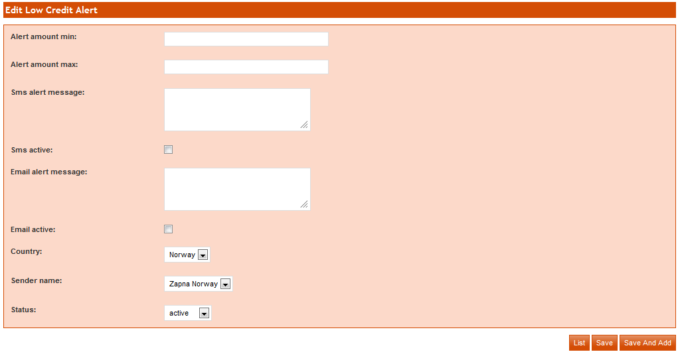

Following are field description:

Alert Amount min: Enter the min amount

Alert Amount max: Enter the max amount

SMS Alert Message: Enter the message which is send through SMS

SMS Active: if you want to send the SMS, click on checkbox

Email Alert Message: Enter the message which is send through Email

Email Active: if you want to send the Email, click on checkbox

**Edit Credit Alert:**

To edit usage alert sender click on Edit D:\wamp\www\Norway\web\sf\sf_admin\images\edit_icon.png button. On next page change your required info then click on **Save** button.If you want to enter more usage alert sender, click on **Save and Add** button.

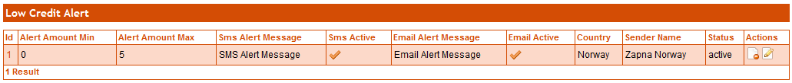

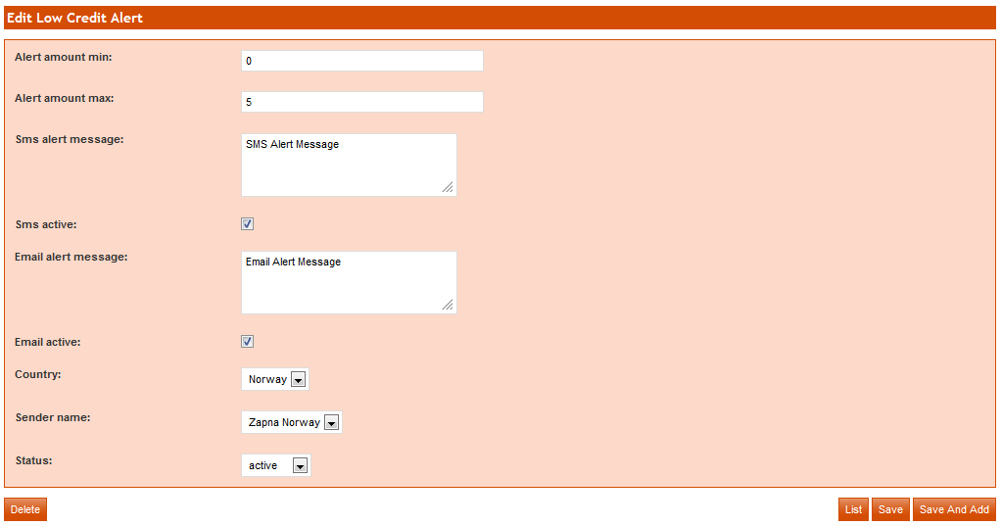

**Delete Credit Alert:**

To delete usage alert, click on delete button.



## Low Credit Alert Sender:

To view the list of Low Credit Alert Sender click on *Low Credit Alert Sender*.



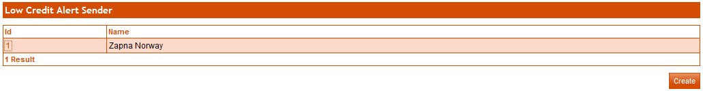

**Create Low Credit Alert Sender:**

To create low credit alert sender, click on **Create** button. Enter mandatory fields and click on **Save** button. If you want to enter more low credit alert sender, click on **Save and Add** button. (mandatory fields are in bold.)



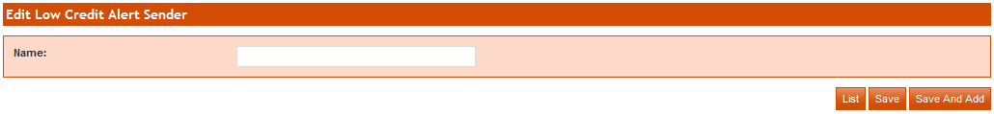

**Edit Low Credit Alert Sender:**

To edit low credit alert sender click on link. On next page change your required info then click on **Save** button.If you want to enter more low credit alert sender, click on **Save and Add** button.



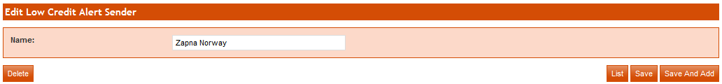

**Delete Low Credit Alert Sender:**

To delete low credit alert sender, click on delete button.



## Telecom Operator:

To view the list of telecom operator click on *Telecom Operator*. These telecom operators are used in Agent and Customer portal.



**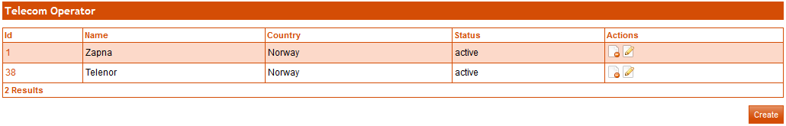**

**Create Telecom Operator:**

Click on ***Create*** button to add new telecom operator. A form will be display, enter info in input fields and click on ***save*** button. If you want to add more telecom operator than click on ***Save and Add*** button.

****

**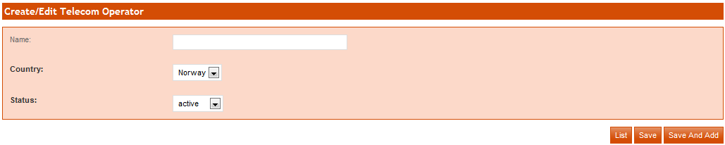**

**Edit Telecom Operator:**

To edit telecom operator, click on edit button. On next page change info then click on **save** button. If you want to enter new telecom operator then click on **Save and Add** button.

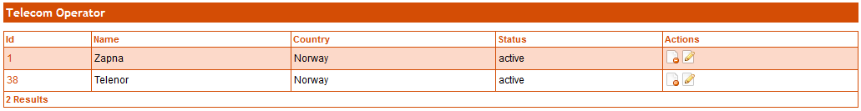

**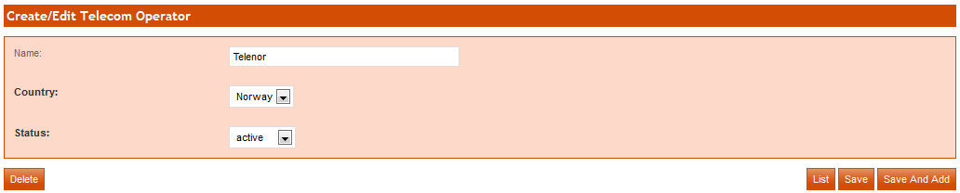**

**Delete Telecom Operator:**

To delete telecom operator click on delete button that is end of each record on list page or on under edit page.





## Deactivate Customer:

To deactivate customer, click on Deactivate eCustomer module, enter customer id (Customer Number in All Registered Customer Module) which is get from All Register Customer module and click on *De-Activate* button. Customer will be deactivating from Zapna No but not from billing server.







## Transaction Description:

To view the list of transaction description click on *Transaction Description*. These transaction descriptions are used in Agent and admin portal for agent and customer refill or charge.



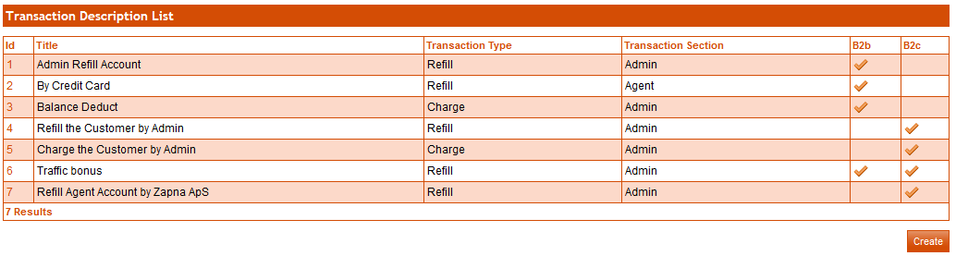

**Create Transaction Description:**

Click on ***Create*** button to add new transaction description. A form will be display, enter info in input fields and click on ***save*** button. If you want to add more transaction description than click on ***Save and Add*** button.



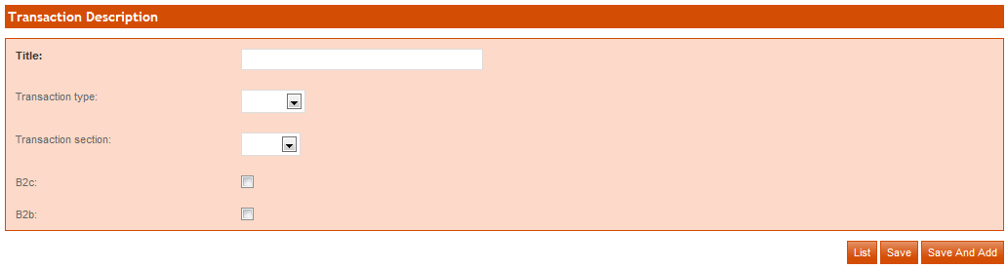

**Edit Transaction Description:**

To edit transaction description, click on link. On next page change info then click on **save** button. If you want to enter new transaction description then click on **Save and Add** button.

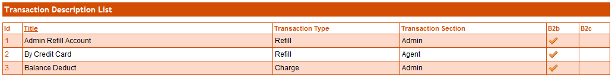

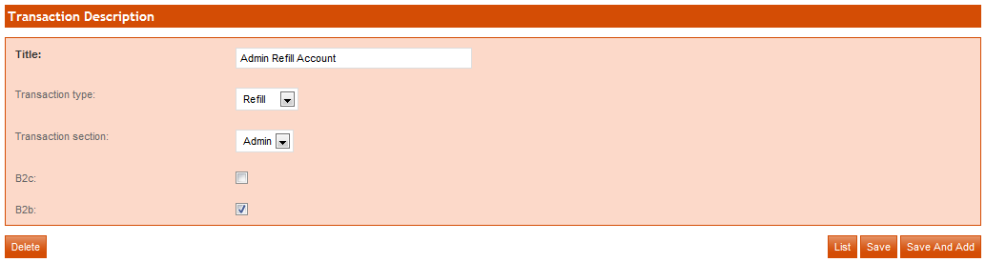

**Delete Transaction Description:**

To delete transaction description, click on delete button that is on under edit page.



## Edit B2B Credit Limit:

To edit credit limit of multiple companies, check on companies which you want to change credit limit, enter credit limit and click on **Save Changes**.



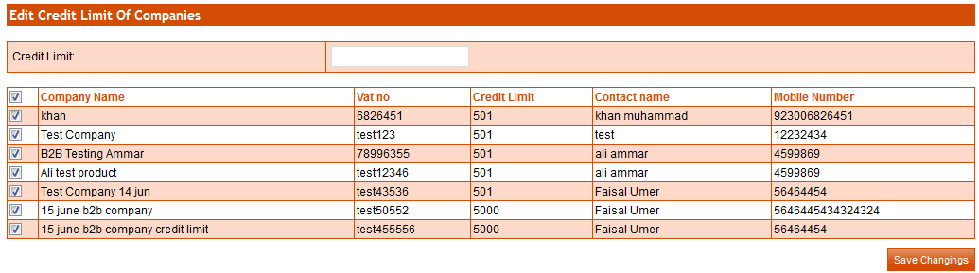

## Logout:

Click on logout button to logout from admin portal.

**C:\Users\fatima\Desktop\Untitled-16 copy.png**